Climate Change Impact on Polar Bear Population in the Beaufort Sea(Arctic Peninsula)

By: Nick Nath, Krystyin Cipriano, Paolo Arciago, Mari Awaisi

## **1. Project Description**

1. **Objective:**

This project aims to investigate the biological trends in polar bear populations, focusing on the relationship between age and year and compare it with the body mass of the bears. Our analysis has been focused on two datasets. One which looked at polar bear mass and length along with bear offspring viability. These data points were important to help us to better understand population dynamics in the Beaufort Sea region of the Arctic peninsula. By examining these demographic and physiological changes, it provided insight into the health and ecology of the bear populations. Temperature levels in the arctic region of Beaufort Sea were also leveraged from a second data set to get insight into how rising temperatures are affecting the overall Polar bear health.

1. **Background:**

This project delves into a comprehensive 36-year longitudinal study of polar bear populations, examining critical data points such as age, mass, total length, and reproductive metrics like the number of cubs. The secondary research aims to shed light on the demographic shifts and physiological changes within the polar bear population, a species profoundly affected by the ongoing climate change crisis. As Arctic ice continues to recede at alarming rates, polar bears face significant challenges in hunting and sustaining their population, making this study crucial for conservation efforts. The data analyzed offers invaluable insights into the health and viability of polar bears in their rapidly changing habitat, providing a barometer for the broader ecological impact of climate change in the Arctic region. This study not only contributes to our understanding of polar bear biology and ecology but also underscores the urgent need for climate action to preserve these iconic animals and their environment.

Additionally, temperatures in the Arctic region were explored during the same 36-year timeframe from a historical climate dataset to see how changes in temperatures would impact the Polar Bear population.

1. **Scope:**

The secondary research component of this project encompasses an extensive analysis of 36 years of data set along with which were meticulously compiled to track and assess the long-term trends in the polar bear population. This secondary data, while robust in its distribution, encountered notable limitations, particularly in the physiological domain, as gut fill, fat in Adipose tissue and percent body fat measurements were absent for all the bears. Such additional body mass sub data is pivotal for understanding the stress and reproductive health of the species, factors that are directly influenced by their dwindling habitat and the resultant nutritional stress. The lack of this data presents a considerable gap in painting a full physiological profile of the population, which is critical for comprehensive conservation strategies. Despite this, the available data sets still provided valuable insights into the general health trends and demographic changes over time. Going forward, this highlights the need for more holistic and continuous data lookup research methods that can capture a wider array of biological indicators, including percent body fat levels, to fully understand the impact of environmental changes on polar bears.

Our second dataset which included meteorological data specifically in the Beaufort Sea area. The scope of this dataset includes various weather parameters such as temperature, visibility, dew point, pressure, humidity, wind speed, and precipitation over a series of dates and times, starting from at least 1981. With latitude and longitude coordinates, it offers granular geographical specificity, potentially allowing researchers to correlate weather patterns with polar bear activities and movements. The inclusion of parameters like snowfall and sea level pressure could be particularly valuable in studying the impact of climate change on polar bear habitats in the Arctic region. This dataset was used to analyze long-term environmental changes and their effects on local wildlife. Given its extensive span over years, we believe it may also provide insights into seasonal weather trends and extreme weather events that would impact the polar bear population.

1. **Methodology:**

By requesting bulk weather historical data from OpenWeatherMap, we were able to utilize this service to get a comprehensive analysis of historical climate data. We used python to read the CSV file and extrapolate the data by creating various data frames to see how temperature is impacted in this specific region over time.

The second dataset of polar bears looked at biological and ecological data of a population in the Beaufort Sea area. The dataset includes various measurements and observations such as date, bear ID, sex, age, total length, skull width, tail length, mass, and other physical and health-related attributes. We examined variables such as age, total length, and mass, and analyzed the population data in python programming language to arrive at the summary below. From a CSV file that contained 22 columns, we created a data frame that looked at the above metrics. Since this was a longitudinal study, we converted the date column from an object into a float which helped us to eliminate non-numerical values to ensure that we prevented any user errors and achieve consistency across the datasets. This helped us prevent the “type” error. Additional data frames were created and “no data” rows were dropped from the original data frame which led us to a cleaner analysis of the data. Sex and reproductive data were examined and plotted to gather the following key findings and highlights.

## **2. Summary**

1. **Key Findings:**

Analysis of the Beaufort weather data does indicate that there has been a warming trend in the Beaufort Sea area. The Polar bear data has indicated that there has been an increase in the average mass of both male and female Polar bears.

1. **Data Highlights:**

* A demonstrated increase of 55.27 Kg in the *mean* body mass of female polar bears.
  + *Females in 1982: 139.83 Kg*
  + *Females in 2017: 195.10 Kg*
* An increase of 60.84 Kg for the male Polar bears’ Mean body mass.
  + *Males in 1982: 236.19 Kg*
  + *Males in 2017: 297.03 Kg*
* The average yearly temperature of the Beaufort Sea area, as studied from 1982-2017, contains a positive slope when plotted on a line-plot map.
  + The linear regression line has a correlation *coefficient of 0.66.*
* Random sampling of polar bears whose mass was tracked over several years were plotted in a chart where after 2010, we saw a downward trend in mass across multiple bears.

* In our clean dataframe where mass data was available, 415 polar bear mass was analyzed with following results:
  + *Mean Mass 186.2 Kg*
  + *Median Mass 182.3 Kg*
  + *Mode Mass 181.4 Kg*
* Further analysis of plotting temperature with mass coinciding with the 36-year period showed that there were 11 years where the temperature was recorded higher than the polar bear mass.
  + The relationship is not entirely inverse as there are years where temperature and mass both increases.
* When we looked at the statistical analysis of mass over the years-
  + Correlation coefficient was very close to zero at *0.014.*
  + The p-value obtained from the test was *0.779* therefore we fail to reject the null hypothesis which means that there is no statistically significant linear correlation between mass and year of the polar bears in the dataset.

## **3. Data Analysis**

1. **Data Description:**

The initial data set under examination encompasses comprehensive information on temperatures, precipitation, humidity, and wind conditions in the Beaufort Sea area. Comprising over 32,000 records, this dataset spans from January 1981 to December 2017 and was meticulously recorded by Open Weather Map.

Concurrently, the second dataset, sourced from the U.S. Geological Survey and U.S. Fish and Wildlife, consists of over 3,000 records pertaining to Polar bears. These records cover the period from 1981 through 2017 and include key parameters such as bear ID, sex, mass, age, length, heart girth, and, in some instances, details about whether a female bear has cubs and the number of cubs. Over the course of 26 years, a total of 297 distinct Polar bears were monitored. This comprehensive dataset provides valuable insights into the demographics and characteristics of the Polar bear population in the region.

In the data sample of 415 polar bears that had mass data across IDs we saw a decline in median mass over time which could signal reduced access to prey due to diminishing sea ice which could affect the ability of bears to hunt. When we plotted our mass in a box plot, we saw an outlier extending to around 118Kg . This reflects nutritional stress within the population.

During periods where a rise in temperature coincides with a decrease in mass, this decrease in mass reflects the impact of warming climate on polar bear habitats and food sources.

1. **Analytical Techniques:**

The examination of the Polar bear dataset begins with an assessment of the gender distribution, delving into the percentage representation of male and female bears. Subsequently, the focus shifts to a subset of bears that have been meticulously tracked for a minimum of three years. Within this subset, the analysis takes a more granular approach by zeroing in on the body mass of Polar bears.

To visualize the fluctuations in body mass, a box plot is employed, providing a dynamic representation of how mass sizes evolve over time (Figure I). Additionally, the *mean* and *mode* of the body mass in the subset population of polar bears are charted on a box plot to highlight central tendencies (Figure VII). A scatter plot of mass over years with a linear regression line is created to gather additional insights and get a statistical summary from the body mass data (Figure XI).

The integration of the weather dataset enhances the analysis, allowing for the creation of a statistical summary specific to Polar bear body mass, organized by decades gave cadence to the overall health of the bear population. This cross-referencing of weather data enriches the understanding of the environmental factors that may influence the observed patterns in Polar bear body mass, offering a holistic perspective on the interplay between climate conditions and the health of the bear population.

1. **Results:**

Examination of the Beaufort weather data reveals a discernible warming trend in the Beaufort Sea region. Concurrently, data on Polar bears indicates a notable rise in the average mass for both male and female individuals. This correlation underscores the intricate relationship between climate patterns and wildlife dynamics, particularly for species such as polar bears that are highly sensitive to environmental changes. The observed increase in bear mass may be indicative of broader ecological shifts and underscores the importance of understanding and addressing the impacts of climate change on Arctic ecosystems.

With regards to the mass data, we saw that bears below the age of 20 had a noticeable decrease in both the median and variability of body mass. In our subset data of polar bears that had mass data over several years, after 2010, there is a downward trend in mass across multiple bears.

## **4. Conclusion**

In conclusion, our analysis of polar bear health and climate change rests on some trends that we have observed from our analysis of the two data sets. The analysis of Beaufort weather data has brought to light a clear and discernible warming trend in the Beaufort Sea region. Simultaneously, the examination of Polar bear data reveals a significant increase in the average mass for both male and female individuals. This correlation serves to emphasize the intricate connection between climate patterns and wildlife dynamics, with a particular focus on species like polar bears, known for their high sensitivity to environmental changes.

This longitudinal study provided the team with the ability to observe trends over an extended period of time. We can draw some additional conclusions as follows:

1. **Impact of Temperature on Habitat:**

The observed rise in Polar bear mass suggests more than just a localized impact—it may be indicative of broader ecological shifts occurring in the Arctic ecosystem. This underscores the urgency of comprehending and addressing the far-reaching impacts of climate change on Arctic ecosystems. As polar bears play a crucial role in the ecological balance of the region, their changing body mass serves as a poignant indicator of the environmental challenges they face. It underscores the importance of proactive conservation efforts and sustainable practices to mitigate the effects of climate change on vulnerable species and preserve the delicate balance of Arctic ecosystems for future generations.

1. **Nutritional Stress:**

The observed fluctuations or decreases in mass might indicate periods of nutritional stress. One hypothesis that we can draw from this is that it can be caused by the changing availability of prey due to warming temperatures and shifting ice patterns. This may make it harder for bears to find food.

1. **Health Indicators/Long-Term Survival:**

We observed through this project that body mass is a key indicator of polar bear health. Consistent declines or increased variability in mass could signal that the overall health of the population is being compromised by environmental changes. The health of the bears, as reflected by their body mass, can have implications for survival and reproduction rates of the species. A declining trend in mass over time might correlate with lower birth rates and higher mortality, threatening the long-term survival of the species. It is important to note that while our statistical correlation highlights potential relationships, it does not establish causation. Detailed ecological studies would be needed to conclusively determine the effects of climate change on polar bear health.

1. **Conservation Mitigation:**

The analysis of polar bear health in relation to mass, temperature, and age along with the importance of seals and sea ice in their diet and the implications of sea level data (which was unavailable for our study), we recommend conservation efforts that address global warming by reducing greenhouse gas emissions. Measures to conserve seal populations so that polar bears have sufficient food resources would be an important prey conservation strategy to employ. Finally, as sea ice diminishes and polar bears spend more time on land, human-bear conflicts can increase. Establishing plans for conflict avoidance and bear-safe waste management practices in Arctic communities would be crucial to the long-term survival of this species.

## **Additional Elements**

**References:**

[OpenWeather Marketplace (openweathermap.org)](https://home.openweathermap.org/marketplace/my_orders)

[Polar Bear Distribution and Habitat Resource Selection Data, Beaufort and Chukchi Seas, 1985-2016 | U.S. Geological Survey (usgs.gov)](https://www.usgs.gov/data/polar-bear-distribution-and-habitat-resource-selection-data-beaufort-and-chukchi-seas-1985)

[ASC Data (usgs.gov)](https://alaska.usgs.gov/products/data.php?dataid=246)

[Without Sea Ice, More Polar Bears Spend Time Onshore, Increasing Potential for Human Interaction | U.S. Geological Survey (usgs.gov)](https://www.usgs.gov/news/state-news-release/without-sea-ice-more-polar-bears-spend-time-onshore-increasing-potential)

[CS_SB_PBearMeasurementData_1981_2017.xlsx](https://1drv.ms/x/s!AloR50zL8f86gq1qdI9nAa-w76pbsQ?e=vaFsjM)

[Beaufort_Sea_Temperatures.xlsx](https://1drv.ms/x/s!AloR50zL8f86gq1s8DW4BlTQmiqZUw?e=jygORo)

**Appendices:**

Figure I

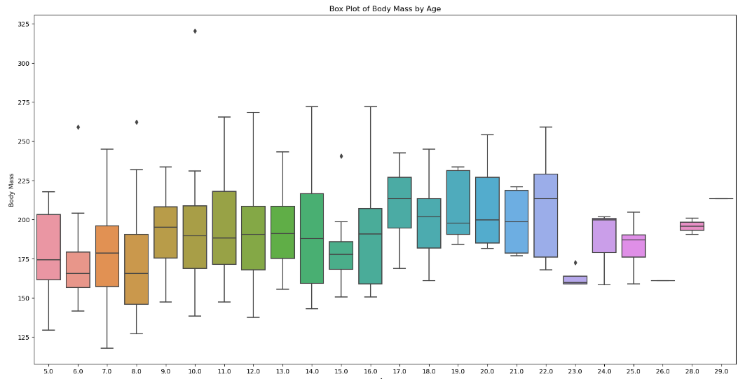

Figure II

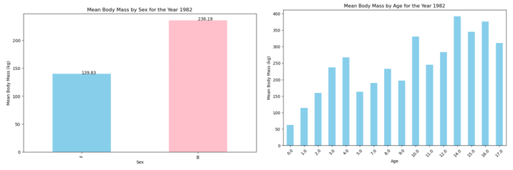

Figure III

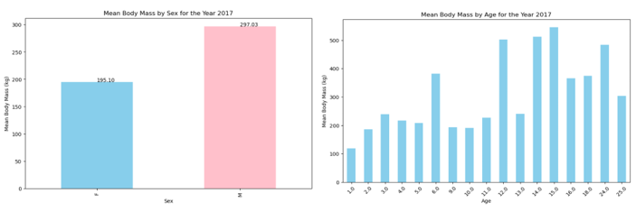

Figure IV

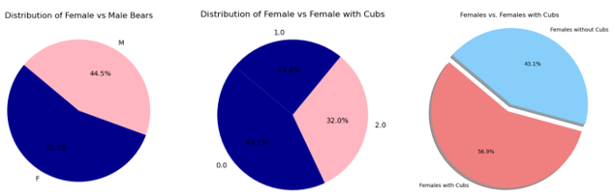

Figure V

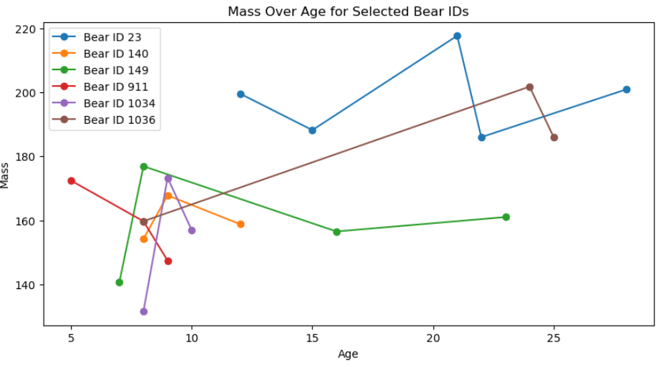

Figure VI

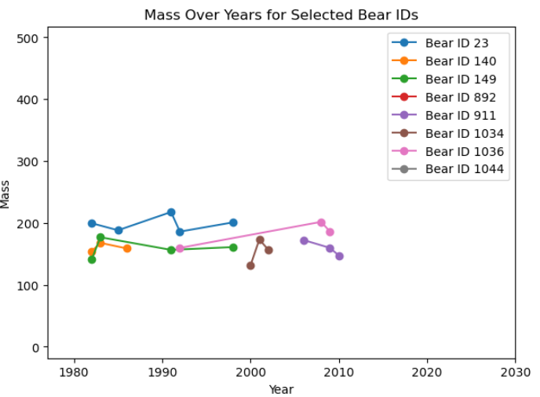

Figure VII

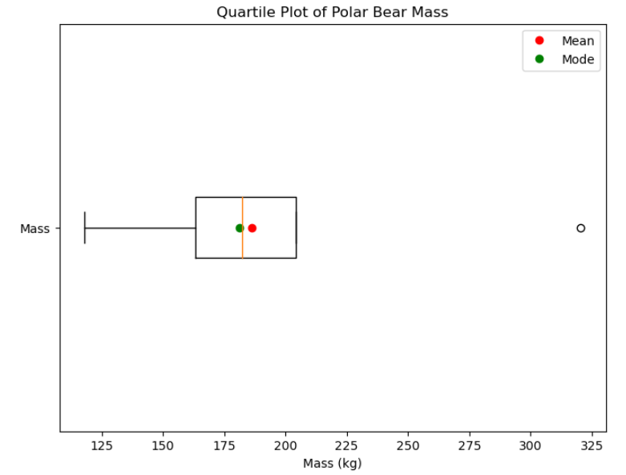

Figure VIII

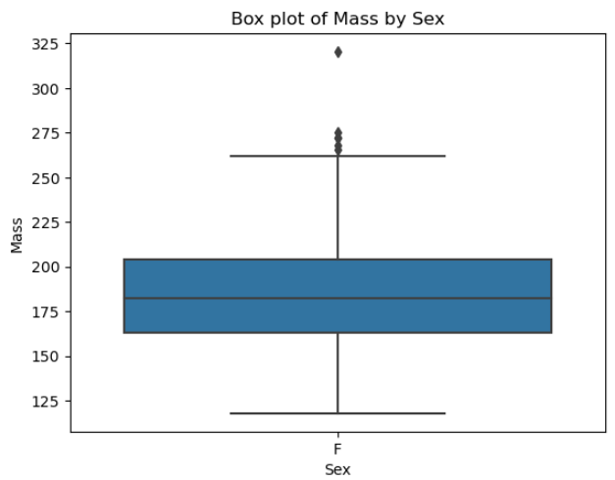

Figure IX

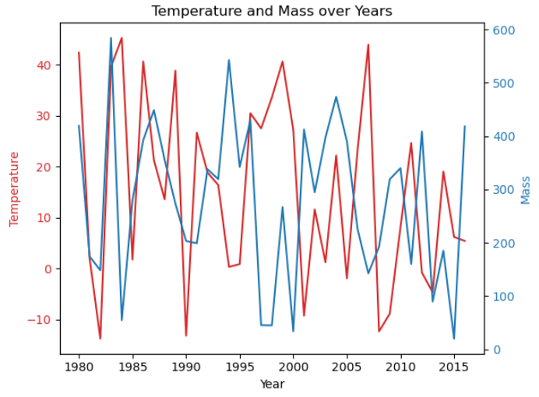

Figure X

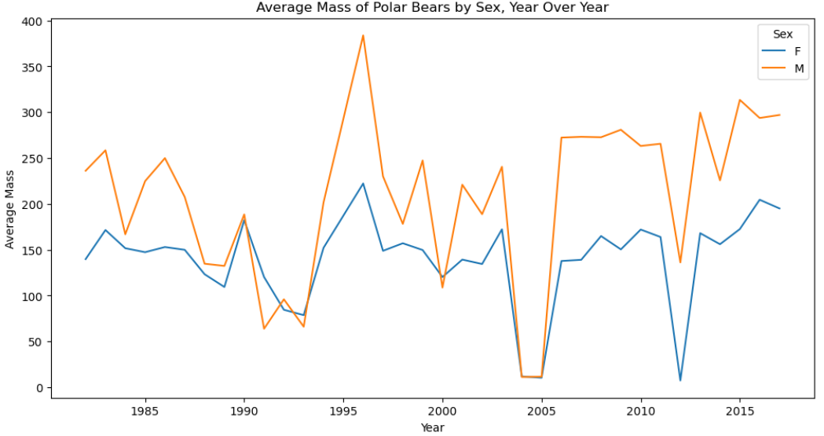

Figure XI

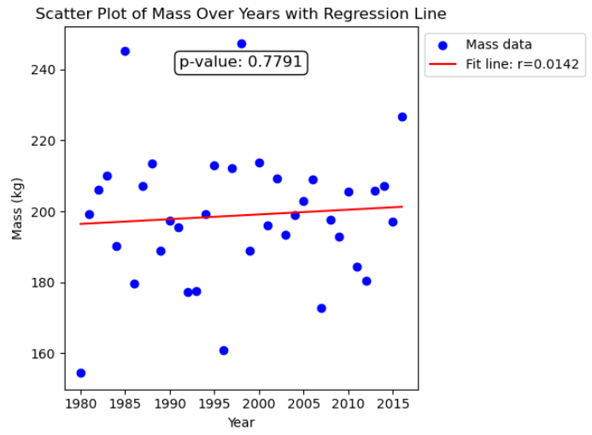

Figure XII

